ICS Cybersecurity Implementation
ISA/IEC 62443 – based approach



Prepared by: Asnali Shamsho
Designation: Process Automation Engineer
Company: Schneider Electric
Table of Content
Chapter 1: Introduction 3
1.1 Project Summary: 3
1.2 Objectives: 3
Chapter 2: System Architecture 4
2.1 Architecture Overview 5
2.1.1 Data flow and communication path 5
2.2 Asset Inventory 5
2.3 Zone definition 6
2.4 Conduit definition 6
Chapter 3: Risk Assessment and Security Requirements 7
3.1 Risk Assessment 7
3.2 Security Requirement 7
Chapter 4: System Designing 8
4.1 IP Allocation 8
4.2 Configuring PDC Server 8
4.2.1 User Account and User Group 8
4.2.1.1 User group 8
4.2.1.2 User Accounts 9
4.2.2 Security Policy and Group Policy Object (GPO) Settings 9
4.3 AVEVA System Platform Hardening 12
4.4 Safet Maintenance Network (SMN) 14
4.5 Configuring EPO Server 16
4.5.1 Registering a PDC in EPO Server 16
4.5.2 Installing Extension and check in Packages 16
4.5.3 Deploy the Trellix Agents to Server Clients and EPO Server 17
Chapter 5: Appendix A 19
5.1 Installing Control Core Service (CCS) Enterprise Edition on a PDC VM 19
5.2 Installing CCS and CS for Domain Client 19
5.3 Installing CCS for Domain Client 20
5.4 Installing CCS for Domain Client 20
5.5 Installing Trellix ePO on EPO VM 21

Introduction

Project Summary:
This project was developed as a practical demonstration to support my application for a Cybersecurity Engineer role, showcasing the application of cybersecurity principles within Industrial Control Systems (ICS) environments. It reflects my technical background in control systems engineering and my focus on securing operational technology (OT) infrastructures.
The project focuses on building a comprehensive OT cybersecurity lab, primarily guided by the ISA/IEC 62443 standard. The lab simulates a realistic industrial architecture, including an enterprise IT network, an OT demilitarized zone (DMZ), control system zones, and a field device zone. The objective is to demonstrate a risk-based approach to OT cybersecurity design, implementation, and validation in alignment with recognized industrial security standards.
Scope:
The lab environment and documentation cover the following:
- Execution of risk assessment, security control testing, and validation of system hardening.
- Integration of enterprise and industrial components within a segmented network architecture (IT, DMZ, OT).
- Implementation of Active Directory-based authentication and authorization.
- Simulation of Foxboro DCS and Modbus communication to replicate OT data flow.
- Deployment of firewalls and access control policies to enforce network segmentation and traffic filtering.
- Deployment and configuration of Trellix Endpoint Security (ENS) and ePolicy Orchestrator (ePO) for endpoint protection and policy enforcement.
- Implementation of Veritas Backup and Recovery for data protection.
- Configuration of WSUS for centralized patch management.

Objectives:
The main objectives of the project are to:
- Design and build a functional OT cybersecurity laboratory environment.
- Conduct a risk assessment to identify potential threats to the lab environment.
- Implement technical and administrative controls to mitigate identified risks.
- Test and validate the effectiveness of implemented security measures.
- Develop professional documentation to demonstrate cybersecurity design and engineering competency.

System Architecture
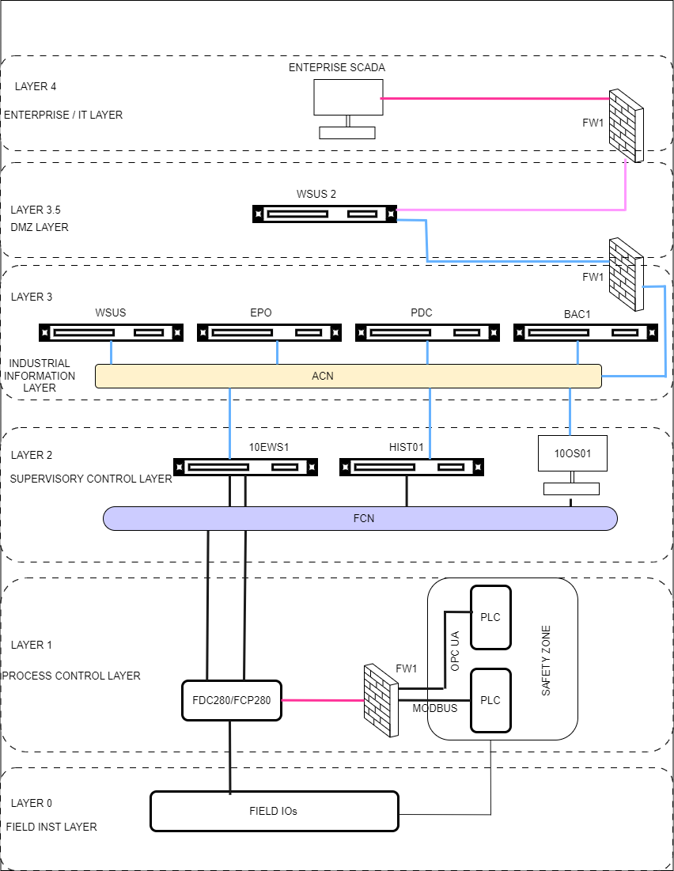
Figure 1. System Architecture

Architecture Overview
The lab environment is designed to represent a simplified industrial automation and control system (IACS) integrated with cybersecurity controls. The architecture follows the Purdue Enterprise Reference Architecture (PERA) where components are logical dived into distinct level and zones.

Data flow and communication path
Communication flows within the architecture are structured according to functional purpose and network segregation:
- Field instruments send process signals to local and remote I/O modules, which are processed by the DCS (FCP280)/PLC controllers within the process control layer.
- The FDC280 functions as a controller/interface component, enabling communication between PLCs and DCS systems.
- FCP280 and FDC280 communicate with the Engineering Workstation (10EWS1), Historian Server and Client (HIST01), and Operator Workstation (10OS1) via the Foxboro Control Network (FCN). This network is dedicated to real-time control, supervision, and operational data exchange.
- The Auxiliary Control Network (ACN) is used exclusively for non-control and cybersecurity-related communications, including authentication, endpoint security management, patch distribution, monitoring, and logging. ACN connects OT endpoints with supporting services such as the Primary Domain Controller (PDC), WSUS servers, Trellix ePO server, BAC1, and authorized operator and engineering workstations.

Asset Inventory
Asset Name | Asset Type | Function | Layer
PLC1, PLC2 | Safety PLC | Execute Safety Logic | Layer 1
FCP280 | Foxboro DCS Controller | Execute Control Logic | Layer 1
FDC280 | Foxboro DCS Controller | Third part integration (Safety PLC) with Foxboro DCS System | Layer 1
10EWS1 | Engineering Workstation | Maintenance & Configuration | Layer 2
HIST01 | Historian | Storing process data | Layer 2
10OS01 | Operator Workstation | Operator control & process monitoring | Layer 2
PDC | Primary Domain Controller (AD Server) | Central Authentication and Authorization for OT devices | Layer 3
EPO | Trellix ePO Server | Central Management of Trellix Endpoint Security for OT devices | Layer 3
BAC1 | Veritas Backup Server | Backup and Recovery Service for OT devices | Layer 3
WSUS | Downstream Window Server Update Services Server | Distribution of Microsoft updates to OT devices | Layer 3
WSUS 2 | Upstream Window Server Update Services Server | Retrieval of Microsoft update from the Internet | Layer 3.5
Enterprise SCADA | Remote SCADA | Remote monitoring and report access | Layer 4
FW1 | Firewall
SW1 | Process Control Network Switch 1
SW2 | Process Control Network Switch 2
SW3 | Safety Maintenance Network Switch
Table 1. Asset Inventory

Zone definition
A Zone is a logical grouping together assets which share common security requirements.
Zone Name | Layer | Description | Typical Assets
Control Zone | Layer 1 | Basic Process Control | FCP280, FDC280
Safety Zone | Layer 1 | Process and Emergency Shutdown (PSD, ESD) | PLC-1, PLC-2
Supervisory Zone | Layer 2 | Operator Control and Monitoring | 10OS01, HIST01 - Client
Engineering Zone | Layer 2 | System engineering, maintenance, and configuration | 10EWS1, HIST01-Server
Cybersecurity Zone | Layer 3 | Cybersecurity Services | PDC, EPO, WSUS, BAC1
DMZ Zone | Layer 3.5 | Buffer between IT and OT | WSUS 2
IT Zone | Layer 4 | Corporate IT systems | Enterprise SCADA
Table 2. Zone Definition

Conduit definition
A conduit is a logical or physical communication path that allows data to flow between two or more zones.
Conduit ID | Source Zone | Destination Zone | Purpose | Protocols/Ports
C-01 | Safety Zone | Control Zone | Transferring Safety Data. If DCS wants to trigger a safety action, it should be hardwired signal. | Modbus TCP port 502, OPC UA TCP port 4840
C-02 | Control Zone | Supervisory Zone | Transferring Process Control & Safety Traffic to Operator workstation and Historian Client | Proprietary Foxboro Control Network (FCN)
C-03 | Control Zone | Engineering Zone | Transferring Process Control & Safety Traffic to Engineering Workstations and Historian Server | Proprietary Foxboro Control Network (FCN)
C-04 | Cybersecurity Zone | Supervisory Zone and Engineering Zone | Transferring cybersecurity traffic (Patch Management, Security Policies, etc..) | TCP/IP, LDAP, HTTPS (ports needed)
C-05 | Cybersecurity Zone | DMZ Zone | Transferring cybersecurity traffic (Patch Management, Security Policies, etc..) | TCP/IP, LDAP(ports needed)
C-06 | DMZ Zone | IT Zone | Controlled Update Sync (one way specify) | HTTPS(ports needed)
Table 3. Conduit Definition

Risk Assessment and Security Requirements

Risk Assessment
The objective of this phase is to identify and mitigate potential cybersecurity risks before implementation.
Risk ID | Threat Scenario | Likelihood | Impact | Risk Level | Security Level
R-01 | Domain Admin Credential theft | Medium | High | High | SL3
R-02 | Engineering Workstation Compromise to unauthorized control logic change | Medium | High | High | SL3
R-03 | Malware propagation via patch updates and Enterprise SCADA | Medium | High | High | SL3
R-04 | Rogue USB Malware injection | Medium | High | High | SL2
R-05 | Safety Logic Encryption | Low | Critical | High | SL4
Table 4. Risk Assessment
A risk assessment was conducted for the pipeline SCADA environment. Based on the identified threats and business impact, Security Level 3 (SL3) was selected as the target security level. Controls were then implemented and validated against IEC 62443 SL3 requirements."

Security Requirement
Foundational Requirement | Security Requirement | Asset
FR 1 - Identification and Authentication Control (IAC) | SR 1.1 – Human User Identification and Authentication | All Assets
 | SR 1.7 – Strength of password-based authentication | All Assets
FR 2 – Use Control (UC) | SR 2.1 – Authorization enforcement/Principle of least privileged RBAC | All Asset
FR 3 – System Integrity (SI) | SR 3.2 – central management and reporting of Malicious code protection | All Asset
FR 5 – Restricted Data flow (RDF) | SR 5.1 - Network Segmentation | All Asset
 | SR 5.2 RE 1 – Zone boundary protection, deny by default allow by exception | All Asset
FR 6 – Timely Response to event (TRF) | SR6.1 - Audit log accessibility | All Asset
 | SR 6.2 – continuous monitoring | All Asset
FR 7 – Resource availability (RA) | SR 7.1 RE 2- denial of service protection – Limit DoS effect to other system or network | All Asset
 | SR 7.3 RE 2 – Control system backup – backup automation | All Asset
Table 5. Security Requirements.

System Designing

IP Allocation
Server name | Description | IP address | Subnet | Default Gateway | DNS
PDC | PDC – ACN Network | 192.168.10.1 | 255.255.255.0 | 192.168.10.10 | 127.0.0.1
10EWS1 | MESH A – FCN Network
 | MESH B – FCN Network
 | 10EWS1 – ACN | 192.168.10.5 | 255.255.255.0 | 192.168.10.10 | 192.168.10.1
HIST01 | ACN Network | 192.168.10.7 | 255.255.255.0 | 192.168.10.10 | 192.168.10.1
EPO | ACN Network | 192.168.10.15 | 255.255.255.0 | 192.168.10.10 | 192.168.10.1
WSUS | ACN Network | 192.168.10.17 | 255.255.255.0 | 192.168.10.10 | 192.168.10.1
WSUS 2 | ACN Network | 192.168.10.20 | 255.255.255.0 | 192.168.10.10 | 192.168.10.1
 | Enterprise Network (EN) | DHCP
BAC1 | ACN Network | 192.168.10.22 | 255.255.255.0 | 192.168.10.10 | 192.168.10.1
FDC280 | MODBUS PORT | 192.168.105.1 | 255.255.255.0
 | OPC UA PORT | 192.168.205.1 | 255.255.255.0
PLC1 | MODBUS | 192.168.100.1 | 255.255.255.0
PLC2 | OPC UA | 192.168.200.1
Table 6. IP Allocaiton

Configuring PDC Server
The Primary Domain Controller (PDC) provides centralized identity, authentication, and directory management services across the Auxiliary Control Network (ACN).

User Account and User Group
User account will be created to follow ISA/IEC 62443-3-3 Human User Identification and Authentication (SR 1.1) and least privileges rule (SR 2.1).
User groups are created to make us easier to assign a security policy. Then users will be assigned to a certain user group according to the requirements.

User group
The following user groups are created.
- Domain Admins – Designeted administrators of the domain
- Dumain Users – All domain users
- Domain Controllers – All domain controllers in the domain
- Domain Computers – all workstation and server joined to the domain
- IA Installer – Installer for the Foxboro DCS Sofwtares
- IA Plant Engineer – Plan Engineer
- IA Plant Operator – Plant Operator
- IA Services – Foxboro DCS Control Software Network Services

User Accounts
The following users are created and assigned to the required groups
User | Description | Assigned Group
ccsdomainadmin | Domain administrator Account | Domain Admin
 |  | Domain User
ccsinstaller | For installation of DCS Software | Domain User
 |  | IA Installer
IAServices | Control Software network account | Domain User
 |  | IA Services
Engineer | Plant Engineer | Domain User
 |  | IA Plant Engineer
Operator | Plant Operator | Domain User
 |  | IA Plant Operator
Table 7. User Account

Security Policy and Group Policy Object (GPO) Settings
To meet Security Level 2 (SL 2) and security Level 1 (1.7), we created a Group Policy Object (GPO) on the Domain Controller to enforce strong password and login rules.
Here are the exact settings configured in the GPO:
Policy Setting | Why we use it | Where it applies
Enforce Password History (8 Password remembered) | Prevents users from reusing recent passwords and bypassing password history controls. (SR 1.5) or SR1.7? | Domain Level
Maximum password age (90 days) | Ensures passwords are changed periodically to reduce the risk of long-term credential compromise.(SR 1.7) | Domain Level
Manimum password age (8 days) | Prevents users from changing passwords repeatedly in a short time to bypass security policies.(SR 1.7) | Domain Level
Minimum Password length (8 character) | Ensures passwords are sufficiently long to reduce the risk of guessing or brute-force attacks. (SR 1.7) | Domain Level
Password must meet complexity (enabled) | Requires a mix of letters, numbers and symbols (SR 1.7) | Domain Level
Store passwords using reversible encryption (disabled) | Prevents storing passwords in a reversible (readable) format, ensuring they remain securely hashed. (SR 1.5) and SR 1.7 | Domain Level
Don't display last signed-in user (enabled) | Prevents disclosure of valid usernames on the login screen, reducing the risk of unauthorized access attempts. (SR 1.4) or SR 1.1? | All Servers and Workstation
Do not require CTRL+ALT+DEL (disabled) | Forces the user to press the keys, which stops fake login screens. (SR 1.1) | All Servers and Workstation
Number of previous logons to cache (5 logon) | Allows the operator to log in locally if the PDC network connection drops (SR 7.1) | All Servers and Workstation
Prompt user to change password before expiration (14 days) | Provides users with advance notice of password expiration to ensure timely password changes without disrupting operations. (SR-1.7) | All Servers and Workstation
Microsoft Network Client: Digitally sign communications (always)- enabled | Ensures integrity of SMB communications and prevents man-in-the-middle attacks. (SR-3.1) | All Servers and Workstation
Microsoft Network Client: Digitally sign communications (if server agrees)- enabled | Ensures integrity of SMB communications and prevents man-in-the-middle attacks. (SR-3.1) | All Servers and Workstation
Microsoft Network Client: sends unencrypted password to third part SMB servers - disabled | Prevents transmission of passwords in an unencrypted format, protecting credentials from interception. (SR-3.1) | All Servers and Workstation
Microsoft Network server: Amount of idle time required before suspending session (15 minitues) | Automatically terminates inactive sessions to reduce the risk of unauthorized access. (SR-2.1) | All Servers and Workstation
Microsoft Network server: Digitally sign communications (always)- enabled | Ensures integrity of SMB communications and prevents man-in-the-middle attacks. (SR-3.1) | All Servers and Workstation
Microsoft Network Server: Digitally sign communications (if client agrees)- enabled | Ensures integrity of SMB communications and prevents man-in-the-middle attacks. (SR-3.1) | All Servers and Workstation
Microsoft Network server: Disconnect clients when logon hours expire (enabled) | Enforces user access restrictions based on defined logon hours to prevent unauthorized system use. (SR-2.1) | All Servers and Workstation
Audit the use of Backup and Restore privileges (disabled) | Prevents system logs from filling up with mundane file-copy entries. | Primary Domain Controller
Shut down system immediately if unable to log security audits (Disabled) | Prioritizes operational availability over rigid IT audit compliance. | All server and Workstation
Allow system to shutdown without having to log on (disabled) | Prevents an unauthorized person from physically pressing a button to turn off a machine. | All server and Workstation
Clear virtual memory pagefile (disabled) | Prioritizes fast system reboot recovery times over data purging. | All server and Workstation
Audit logoff (success) | Logs user session termination for accountability and forensic analysis. (FR-6) | All server and Workstation
Audit logon (success, failure) | Records login attempts to detect unauthorized access and brute-force attacks. (FR-6) | All server and Workstation
Audit other logoff/logon (success, failure) | Captures custom remote terminal sessions and RDP login handshakes. | All server and Workstation
Audit special logon (success) | Logs privileged logon events, including administrator access. (FR-6) | All server and Workstation
Audit Policy change (success, failure) | Detects unauthorized modifications to security settings and policies. (FR-6) | All server and Workstation
Audit sensitive Privileges use (success, failure) | Tracks when an account calls highly sensitive tasks like changing system time. | All server and Workstation
Audit system integrity (success, failure) | Detects changes to system files and security configurations. (FR-3) | All server and Workstation
Prevent access to registry editing tools (enabled) | Prevents unauthorized modification of system configurations and security settings. (SR-2.1) | Plant Engineer and Plant Operator
Prohibit access to control panel and PC Setting (enabled) | Restricts users from modifying system settings, reducing risk of misconfiguration. (SR-2.1) | Plant Operator
Do not add shares of recently opened documents to Network location (enabled) | Reduces exposure of sensitive information and limits user activity traces. (SR-3.1) | Plant Operator
Hide and disable all items on the desktop (enabled) | Keeps the HMI environment pristine and blocks users from running unapproved shortcuts. | Plant Operator
Remove access to use all Windows update features | Prevents users from initiating unauthorized system updates, ensuring controlled patch management. (SR-3.2) | Plant Engineer and Plant Operator
Table 8. GPO Settings
Here are some of the GPO setting screenshot
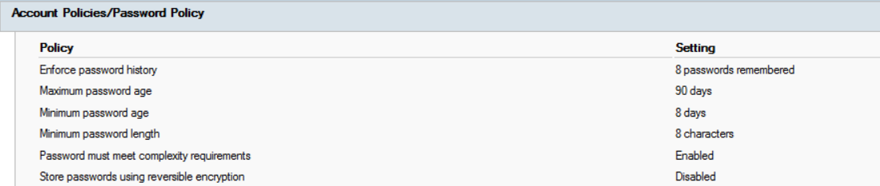
Figure 2. Password Policy
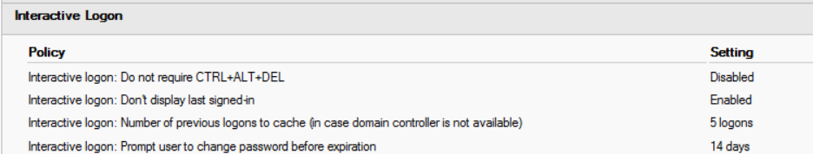
Figure 3. Interactive Logon

AVEVA System Platform Hardening
- Configure the Control Software Network Account
- Set the authentication mode for AVEVA System Platform to OS Group based (or OS User) so every operator/engineer authenticates against Windows/AD before configuration or runtime access.
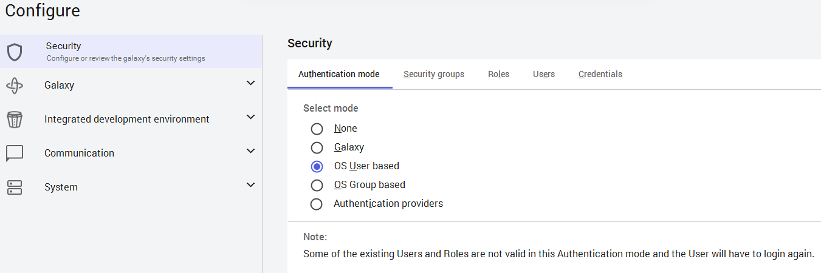
- Set the security authentication in Framer as OS User
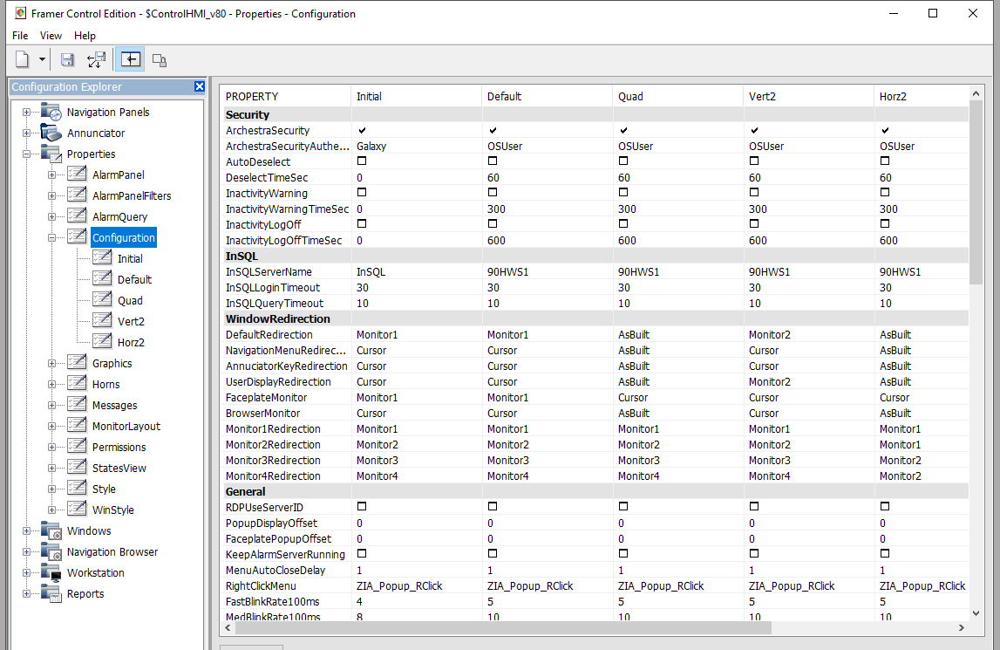
- Set the required permission for users for accessing the Control HMI (CHMI).
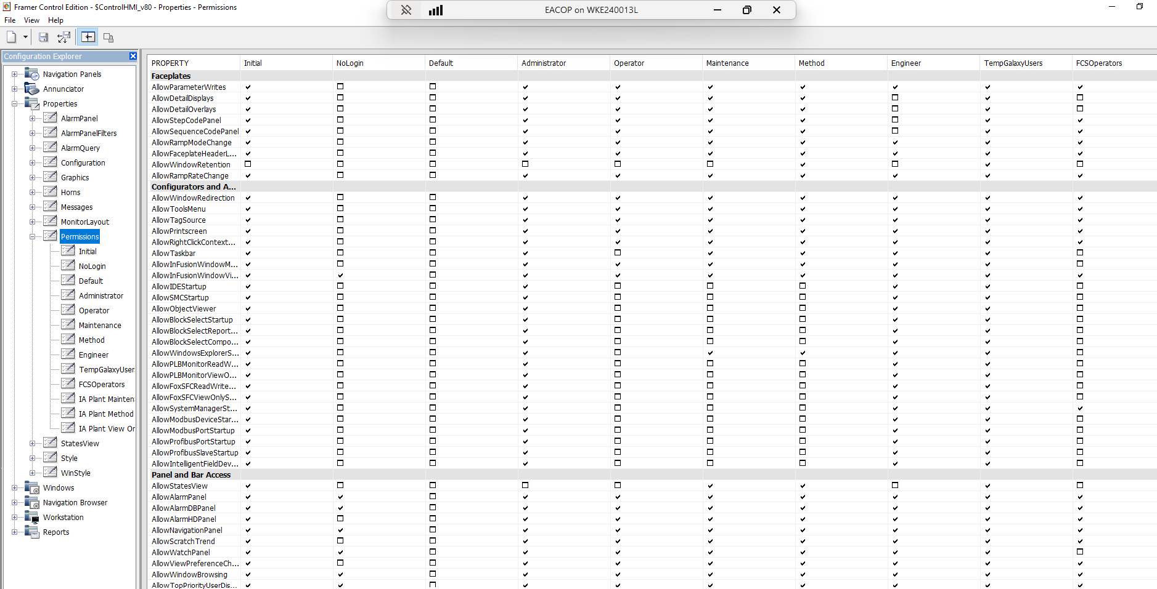

Safet Maintenance Network (SMN)
PLCs will be connected to FDC280 through Firewall andSMN Switch. The SMN will be on Vlan 200.
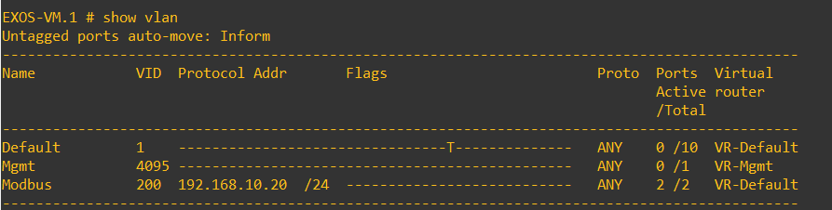
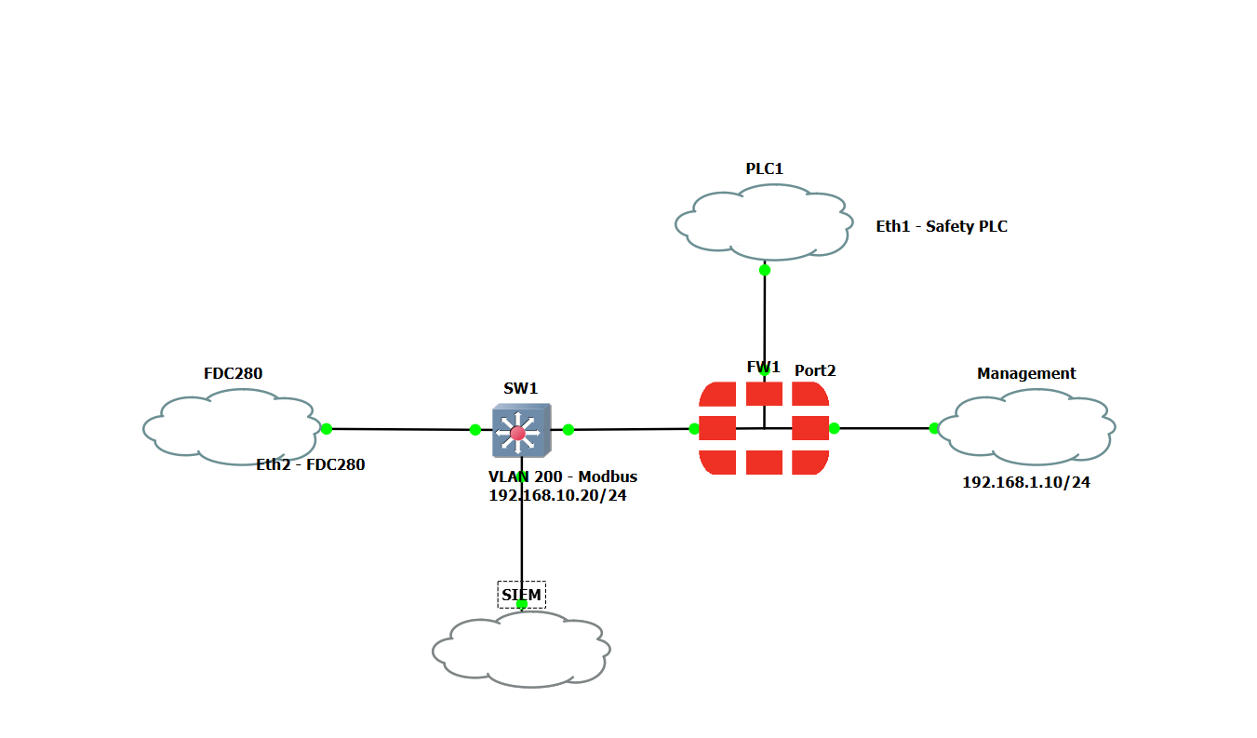
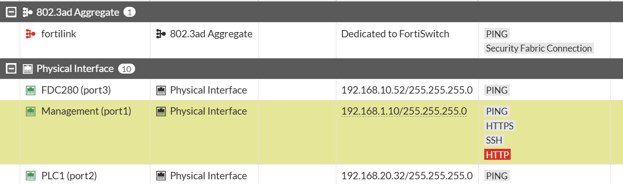
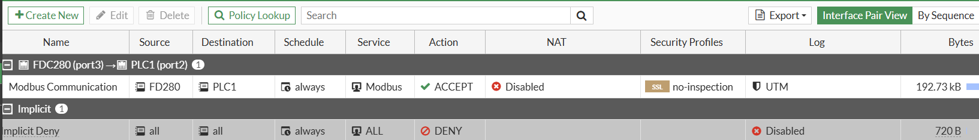
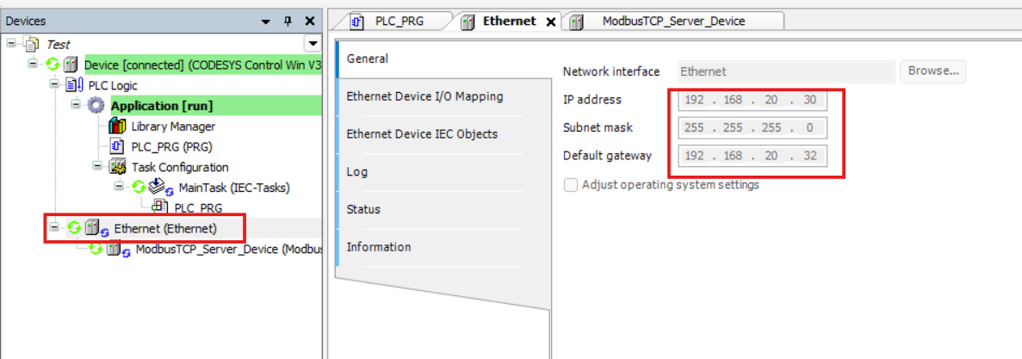

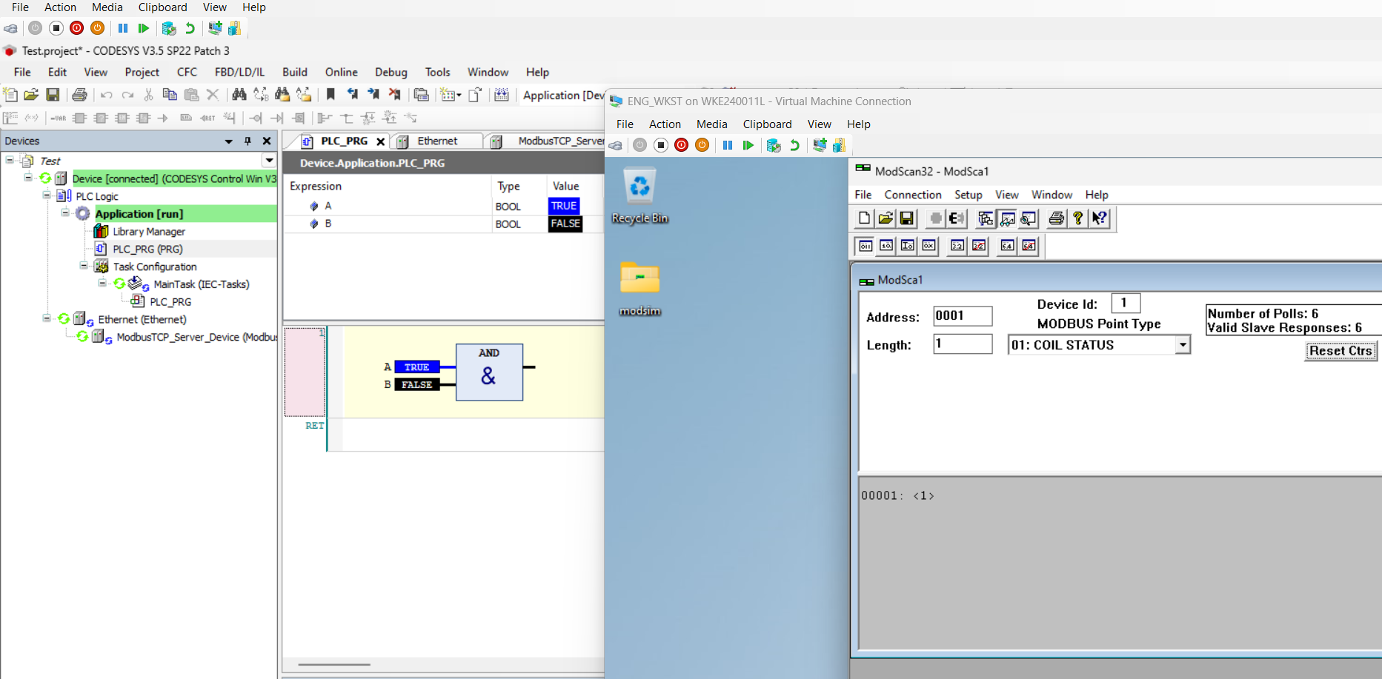
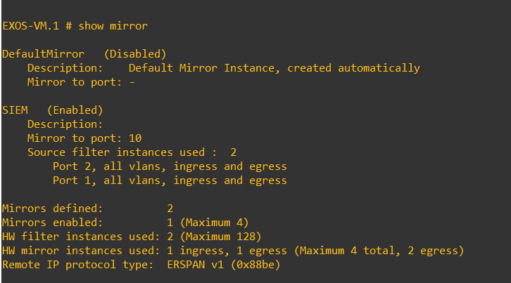

Configuring EPO Server

Registering a PDC in EPO Server

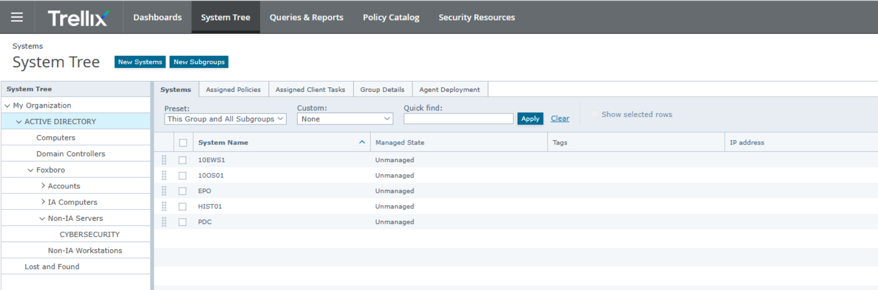
Figure 4. Registering PDC in EPO Server

Installing Extension and check in Packages
The following extension were installed
            - Trellix Agent
            - Endpoint Security
              - Endpoint Security Platform
              - Endpoint Security Threat Prevention
              - Endpoint Security Web Control
            - Solidcore
            - Rogue System Detection
            - Data Loss Prevention
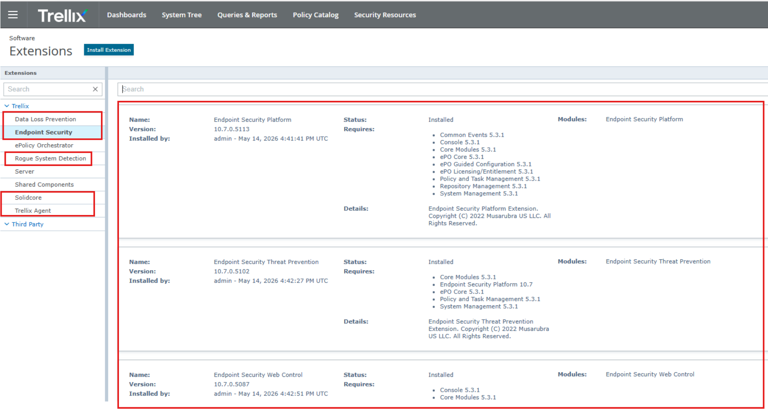
Figure 5. Extension Installation
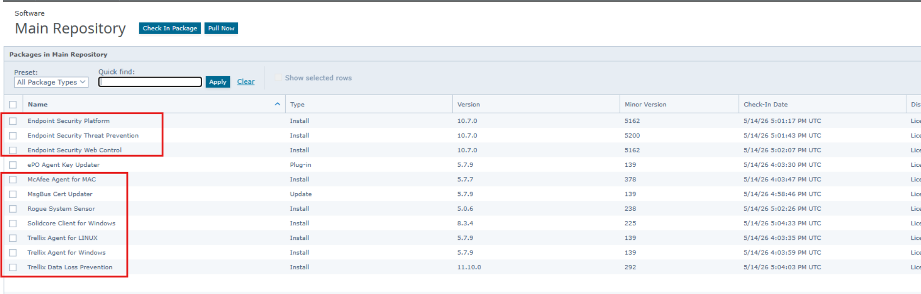
Figure 6. Package Installation

Deploy the Trellix Agents to Server Clients and EPO Server
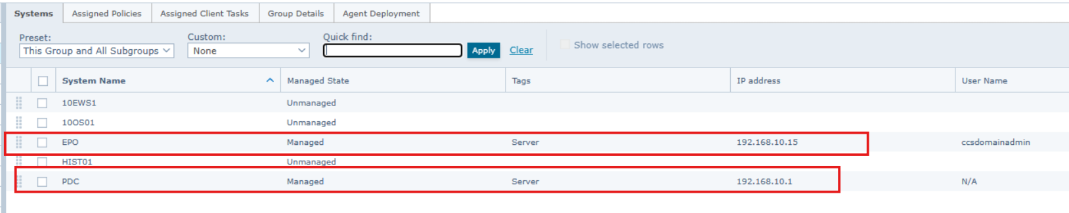
Figure 7.Trellix Agent Deployed to EPO Clients

Appendix A

Installing Control Core Service (CCS) Enterprise Edition on a PDC VM
- Assign ACN Virtual Switch to PDC VM.
- Installing Window server 2022 to the PDC VM.
- Rename the server’s name to PDC.
- Assign the IP address, subnet, default gateway of the ACN virtual adapter as described to IP allocation.
- Install LGPO.
- Install Trellix ENS.
- Run full scan of the system to confirm no virus are present.
- Disable Trellix Endpoint Security’s “Scan trusted installers” feature.
- Install Enterprise Edition CCS v9.8 for New Off-Control Domain Controller.
- Enable Trellix Endpoint Security’s “Scan trusted installers” feature.

Installing CCS and CS for Domain Client
- Assigning ACN, MESH A, MESH B Virtual switches to 10EWS1 VM
- Installing Window server 2022 to the 10EWS1 VM
- Rename the server’s name to be the same as defined on system definition (10EWS1)
- Assign the IP address, subnet, default gateway of the ACN, MESH A, MESH B virtual adapter as described to network description.
- Adding 10EWS1 IP address to the forward lookup zone on a PDC
- Verify you can ping PDC using 192.168.10.1
- Verify you can ping PDC using FQDN: pdc.lab.local
- Verify the nslookup command shows the PDC’s FQDN or it’s IP address.
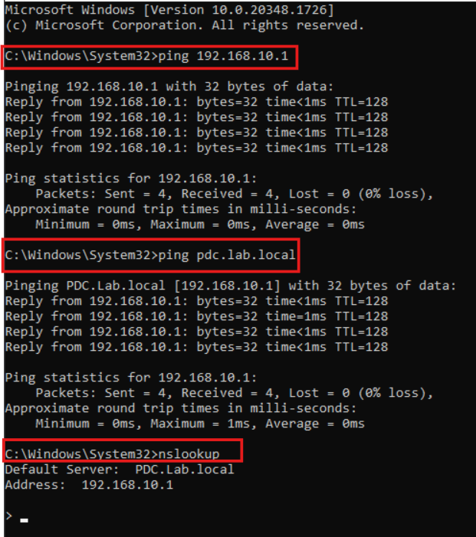
- Set the ACN IP to Automatic (use DHCP) and obtain DNS automatic.
- Install LGPO.
- Install Trellix ENS.
- Run full scan of the system to confirm no virus are present.
- Disable Trellix Endpoint Security’s “Scan trusted installers” feature.
- Installing System Manager.
- Install Enterprise Edition CCS v9.8 for New Off-Control Domain Client.
- Installing Control Software V8.0.

Installing CCS for Domain Client
- Assigning ACN, MESH A, MESH B Virtual switches to HIST01 VM
- Installing Window server 2022 to the HIST01 VM
- Rename the server’s name to be the same as defined on system definition (HIST01)
- Assign the IP address, subnet, default gateway of the ACN, MESH A, MESH B virtual adapter as described to network description.
- Adding HIST01 IP address to the forward lookup zone on a PDC
- Verify you can ping PDC using 192.168.10.1
- Verify you can ping PDC using FQDN: pdc.lab.local
- Verify the nslookup command shows the PDC’s FQDN or it’s IP address.

- Set the ACN IP to Automatic (use DHCP) and obtain DNS automatic.
- Install LGPO.
- Install Trellix ENS.
- Run full scan of the system to confirm no virus are present.
- Disable Trellix Endpoint Security’s “Scan trusted installers” feature.
- Installing System Manager.
- Installing Control Software V8.0 and select Historian Server, Historian Data Collector and Historian Client.

Installing CCS for Domain Client
- Assigning ACN, MESH A, MESH B Virtual switches to 10OS01 VM
- Installing Window server 2022 to the 10OS01 VM
- Rename the server’s name to be the same as defined on system definition (10OS01)
- Assign the IP address, subnet, default gateway of the ACN, MESH A, MESH B virtual adapter as described to network description.
- Adding 10OS01 IP address to the forward lookup zone on a PDC
- Verify you can ping PDC using 192.168.10.1
- Verify you can ping PDC using FQDN: pdc.lab.local
- Verify the nslookup command shows the PDC’s FQDN or it’s IP address.

- Set the ACN IP to Automatic (use DHCP) and obtain DNS automatic.
- Install LGPO.
- Install Trellix ENS.
- Run full scan of the system to confirm no virus are present.
- Disable Trellix Endpoint Security’s “Scan trusted installers” feature.
- Installing System Manager.
- Installing Control Software V8.0 and select Engineering Client.

Installing Trellix ePO on EPO VM
      - Assign ACN Virtual Switch to EPO VM
      - Installing Window server 2022 to the EPO VM
      - Rename the server’s name to be EPO
      - Assign the IP address, subnet, default gateway of the ACN virtual adapter as described to network description.
      - Add EPO server to the Domain Controller and login as Domain Admin Account.
      - Install Trellix ENS
      - Ensure IE ESC is off for both administrator and users
      - Install SQL server express 2022
      - Install ePolicy Orchestrator
      - Set IE ESC is on for both administrator and users

